***EXPERIMENT NO : 4A***

**Python programs to implement User-defined modules/packages and import in a program**

***NAME : AKASH RAMKRIT YADAV ID.NO: VU4F2122016***

***BATCH : A BRANCH : IT DIV : A***

***Aim :-***  python programs to implement User-defined modules/packages and . . import them in a program

***THEORY:***

***OUTPUT:***

*Python 3.11.0a4 (main, Mar 13 2023, 10:57:32) [MSC v.1929 32 bit (Intel)] on win32*

*Type "help", "copyright", "credits" or "license()" for more information.*

*#AKASH YADAV ID.NO:VU4F2122016 EXP:4A DATE:13/3/2023*

## Create a Module

To create a module just save the code you want in a file with the file extension .py:

### **Example**

Save this code in a file named AKASH.py

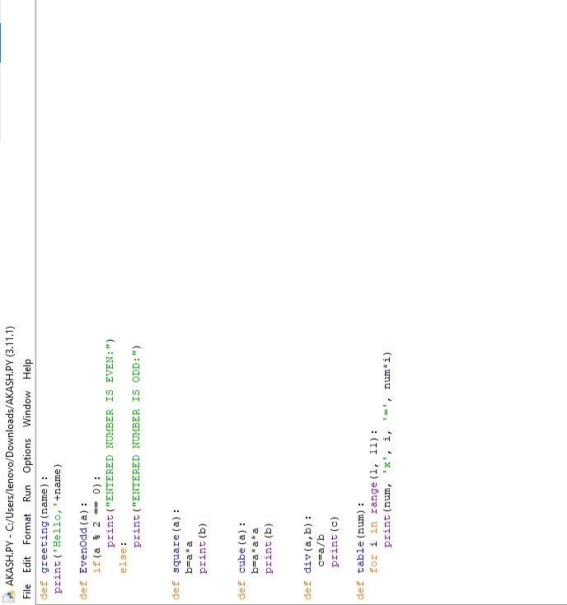

## Use a Module :

Now we can use the module we just created, by using the import statement:

### **Example**

Import the module named mymodule, and call the

greeting function:

EvenOdd function:

Square function:

Cube function:

Div function:

Table function:

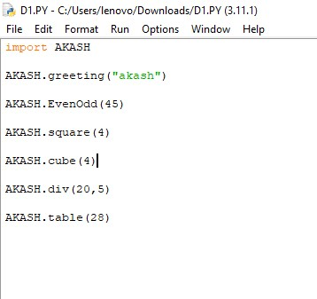

***OUTPUT:***

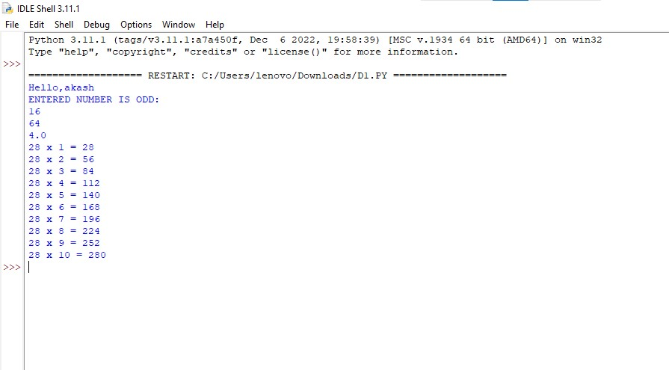

***EXAMPLE: 2***

**Create a Module:**

*from tkinter import \**

*import tkinter.messagebox*

*def gpa_calculator(grades):*

*points = 0*

*i = 0*

*grade_c = {"A":4,"A-":3.67,"B+":3.33,"B":3.0,"B-":2.67, "C+":2.33,"C":2.0,"C-":1.67,"D+":1.33,"D":1.0,"F":0}*

*if grades != []:*

*for grade in grades:*

*if grade not in grade_c:*

*return "Invalid"*

*points += grade_c[grade]*

*gpa = points / len(grades)*

*return gpa*

*else:*

*return None*

*class App:*

*def __init__(self, parent):*

*self.parent = parent*

*self.frame_1 = Frame(parent)*

*self.frame_1.pack()*

*self.sub_count = 1*

*self.subs = []*

*Label(self.frame_1, text=" AKASH YADAV \n Enter Grade :").grid(row=self.sub_count-1, column=0)*

*self.subs.append(Entry(self.frame_1))*

*self.subs[self.sub_count-1].grid(row=self.sub_count-1, column=1)*

*self.btn_1 = Button(parent, text="Add Courses !",*

*command=self.add_courses)*

*self.btn_1.pack(pady=8)*

*self.btn_2 = Button(parent, text="Calculate GPA",*

*command=self.calc_CG)*

*self.btn_2.pack(pady=8)*

*def add_courses(self):*

*self.sub_count += 1*

*Label(self.frame_1, text="Enter Grade :").grid(row=self.sub_count-1, column=0)*

*self.subs.append(Entry(self.frame_1))*

*self.subs[self.sub_count-1].grid(row=self.sub_count-1, column=1)*

*def calc_CG(self):*

*grades = []*

*for sub in self.subs:*

*if sub.get() != "":*

*grades.append(sub.get())*

*tkinter.messagebox.showinfo("Predicted CGPA ", str(gpa_calculator(grades)))*

*root = Tk()*

*app = App(root)*

*root.mainloop(*

## Use a Module :

*)*

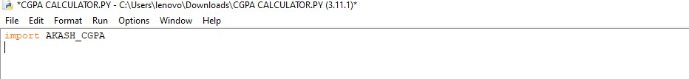

OUTPUT:

